Pears, pistachios, pencils and punctuation: performative encounter and the art of conversation

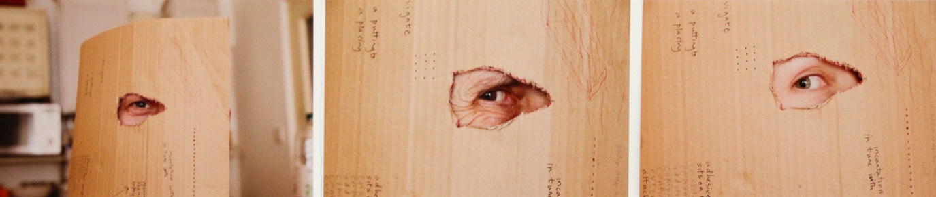

Figure 1: © the authors (all images).

The field of operation
We are three critically-disposed artist-educators (fig. 1) who meet regularly, operating within an academic notion of collaborative research, each bringing a practitioner’s sense of co-production to the (figurative and literal) table. There are no rules as such, though certain characteristics have evolved as recurrent aspects, facilitating a semi-structured coherence. The date, time and place are arranged in advance and a habit of sitting around a large table covered with a sheet of paper, assorted implements, materials and objects (Fig.2) has evolved as a typical modus operandi. Food and drink are consumed but also serves as additional material and conceptual matter. Reading matter also surfaces, allowing other voices to participate and offer supporting critical reflection. The surface is a support, which in the manner of the word’s etymology (from the Latin supportare) brings forward or carries (portare) ‘up from under’ (sub).
That which is supported by the paper enables crossing points between the hidden and the visible to be afforded to perception (Gibson 1979). The table as a kind of platform supports the paper (another platform) onto which traces of the conversation are mapped and materialised as a topological strata of experiential exchange. Although for the most part we are seated, the field of operations might be extended through the introduction of a new object or a movement in the realignment of a point of view as the experiential encounter unfolds. Above all we make stuff happen: an apparatus of thought, a diagrammatic transaction, a collaborative orientation, a correspondence of matter and meaning and the experience of small pleasures or catastrophes arising from the challenges of the visual-material-verbal dialogue.
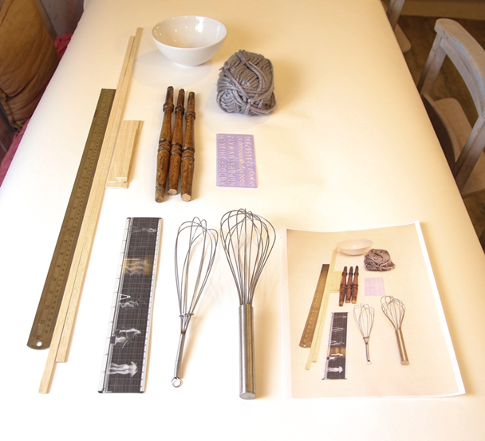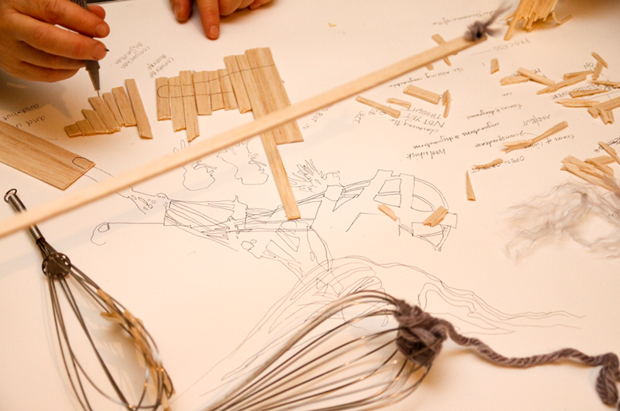

Figure 2
The large sheet of paper serves as a temporary surface on which conversations between subjects and objects gradually unfold. Drawings, diagrams, marks, stains, words, crumbs, nut shells, half-empty glasses, found materials or random objects in the vicinity might participate in our conversation and the flow of interaction. This theatre of operations is also an operating theatre. The manner of operation and the portable mobile framework which forms the apparatus within which we orient the activity of shared experience is alive with moments of potential discovery or imminent systems collapse. A carefully balanced pistachio shell falls and the constantly forming assemblage is realigned and revitalised. The table and its continuously transformed surface also becomes an improvised theatre (in a staged sense) which articulates a play of correspondences, dissonances, affordances and intensities of intersecting ideas, objects and actions. The Latin for table-cloth, mappa, is also apt in this context, thus as the table is laid and re-laid an unfolding orientation is marked out and an unfamiliar terrain is made known.
From the outset, we engage in conversation, gradually drawing aspects of the material world into our exchanges until, as if imperceptibly, the status of the visual-material domain becomes essential to the ongoing discourse. Material conversations begin to eschew the limitations of words without foregoing the critical apparatus through which the semantic of knowing is typically shaped. Words are written down, where it is as if they are experienced as a material or experiential presence and as an agent of dialogue. In testing the boundaries of knowing, the taste of words and the flavours of gestures are shaped according to a responsive play of associations. We enter the alimentary as metaphor, stumbling as if by chance on the concept of collaborative digestion, questioning the potential of a digestive tract of knowing. The opening of nuts, the forming of constructions with the shell detritus, the eating of the nut and the ongoing discussions of visceral and material bodies pull our thoughts and action towards a ‘body without organs’ (Deleuze and Guattari 1988). These embodiments are simultaneously mapped together as a diagram of conjunctions from which further action and reflection can be drawn in and out. Digestion follows.
Conversations are shaped through embodied actions, intersecting with objects and the environment. This semi-improvised research-in-action functions, crucially, as the embodied trace of a live exchange: a form of artistic practice. It is this trace and this practice that the present text and visual documentation seek to map. This is performative research-in-the-making and a form of artistic practice, with evolving outcomes inviting scrutiny and engagement.

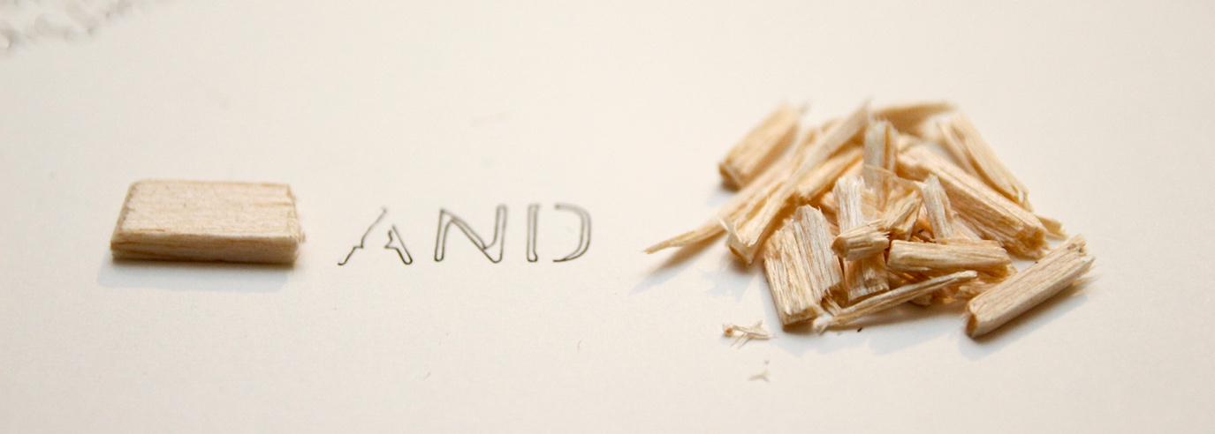

Figure 3

Speech acts and the materiality of words
W O R D S can be materialized and their materiality matters. Alone and floating, precise in nomenclature, elaborate and rule-sensitive in syntax, abrasive or seductive in conjunction, subversively disrespectful, teeming with conjecture, trumped-up as powerful, words are tools which give shape to invention and flesh to reflection. As the vocal folds of the voice box are energized into the sounds of speech, words are shaped into being. They become objects as they break the air, as they are shaped into existence, to be encountered by others and to invite response. Even in their ambiguity words become articulate, giving names to what otherwise would be a flow of undifferentiated matter.
Our conversation assumes a form of objectivity as words and gestures are exchanged, overcoming the boundaries of selfhood and opening to transformation, transaction, translation and dialogue. Dialogue bridges differences or forms intractable knots of unknowing which cry out to be unravelled, to be set straight. Sometimes utterances are grammatically aligned or syntactically fashioned, while more often they express the residue of half formed thoughts. Even barely articulate intonations, pauses and the pace of breathing are indicative of legitimate meanings or experiences which cannot be realized as speech. They may be an intrinsic part of the complex apparatus within which conversation is embedded. Circulated and exchanged in conversation, words are accompanied by gestural movements of the eyes or lips, shoulders or hands, even of the whole body at work in a performative production giving birth to a chain of thoughts (which may be interconnecting, but can also erupt as if propelled by chance). A reflexive awareness kicks-in and our utterances become resources.
For Mikhail Bakhtin utterance and word are cut from the same cloth, formed through and embedded within the dialogic of social relations and inseparable from specific contexts such as place and historical moment (Bakhtin 1986). Spoken, uttered, spluttered or pronounced as emissions of the working body in the course of socially engaged encounter, thinking shapes what comes forth. A response to what comes forth is validation that, however dimly uttered, something spoken really matters, in a manner that corresponds to the articulacy of materials and objects. This correspondence between words and objects as experienced in our practice opens up a boundary-arena between otherwise distinct contexts in which words signal representation and objects are experienced directly as material. For Bakhtin,"(t)he word lives, as it were, on the boundary between its own context and another, alien, context" (_____1981: 284); in our practice it is this boundary that enables an intermingling between the mattering of words and the mattering of matter.
We have extended Bakhtin’s sphere of speech communication to include how materials and objects also function as agents of conversation and dialogue. Thus, whether spoken, written, fabricated or found, matter constitutes a field of ‘utterance’ in Bakhtin’s sense, in which individual units are
“not indifferent to one another and are not self-sufficient; they are aware of and mutually reflect one another... Each utterance refutes, affirms, supplements, and relies upon the others, presupposes them to be known, and somehow takes them into account... Therefore, each kind of utterance is filled with various kinds of responsive reactions to other utterances…..” (_____ 1986: 81).
Always acting together, whether in parallel or symbiotically, the verbal and non-verbal form an intrinsic and interwoven aspect of that which is uttered in the dialogic space of our tabled exchanges. This dialogic space extends through writing as if in another register, as in the writing and imagery of this text, but is always brought back to the table.
The fluid intermingling between word and object or word and material, as encountered in our practice, might also figure as a play between anxiety and resolution through which, in Roland Barthes words, we are compelled to ‘fix the floating chain of signifieds in such a way as to counter the terror of uncertain signs’ (Barthes, 1977: 39). Our approach to performative materiality tolerates the anxiety that can erupt between materiality and representation. It functions dialogically as a bulwark to what the physicist and critical theorist Karen Barad refers to as the ‘sticky problem of humanity’s own captivity within language’ (Barad 2007: 137).
For Barad, ‘performative understanding of discursive practices challenges the representationalist belief in the power of words to represent pre-existing things’ (____2007: 133; original emphasis). In its place, material offers a ‘contestation of the excessive power granted to language to determine what is real’ (____ 2007: 133). Matter, she argues, ‘is substance in its intra-active becoming – not a thing but a doing, a congealing of agency’ (____ 2007: 171; original emphasis). Barad sees this crucial intra-action as a ‘mutual constitution of entangled agencies’ (____ 2007: 33; original emphasis) which originates from within matter whether human or non-human. Whereas Bakhtin’s focus on the sphere of speech communication (hence the human) may thwart material discursivity, material contexts of knowing are considered as primary for Barad’s posthumanist account.

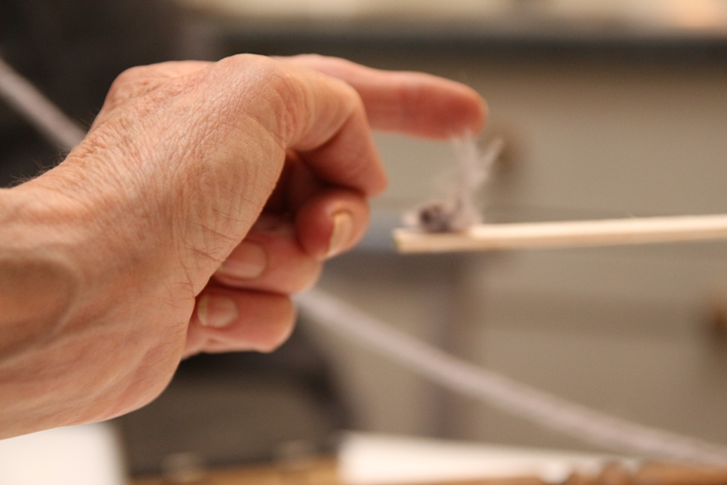

Figure 4

In attempting to balance these positions in conversation, we might resort to a delicately poised gesture (Fig.4). Physical gestures matter; as words gained advantage through evolution as a medium of communication a consequence of great significance was unleashed: the hands were freed to intersect with language in as yet uncharted ways (Corballis 2003: 213). Small acts of territorialisation, such as writing words down, putting them on (our) tabled paper, shaping them in ink or impressing them into material can mark a speech event or a gesture, or both at once. When the word-as-object and the object-as-utterance are captured (inscribed, printed, taped, photographed) they begin to take on a life apart from their source, out in the world.

Conversation Pieces as intra-action
Our utterances do not follow a grammatical structure like a sentence, they are units of communication that are unstable, dynamic, multivalent and dependent upon the context of the material conversation for completeness. One might consider them as orientational utterances of matter that pull and push conversation along different vertices. Things settle and perch. They are pinned down, vectors are drawn, orientations are made. There are fractures, eruptions, seizures; a dissolution before reforming, they are like short staccato movements of a mini-theatre, the strophes and antistrophes of a Greek play. Events are staged, crescendos of meaning are collected for restaging. Reflection and critical thought chime, resonate or dissonate as the meetings chorus.
Entanglements of matter and meaning approach communality as a performative practice. For Barad, such performativity is closely aligned to agency as ‘a matter of intra-acting’ and ‘an enactment….’ in which ‘performativity allows matter its due as an active participant in the world’s becoming, in its ongoing intra-activity’ (____ 2007: 136, 178; original emphases). Material-discursive practices are envisaged as an intra-connecting network of apparatus-like phenomena in which matter is charged with agency and hence with that which matters (in both senses of the word). Typically, an apparatus is a kind of tool which might be imagined as a prosthesis of some kind. From the Latin apparatus it not only carries the sense of tools adapted to a purpose but also a notion of preparation, of things being prepared to come into being. Significantly, matters of identity and subjecthood also become enmeshed as ‘apparatus’ in Barad’s performative-material network, thus ‘…..apparatuses are discursive practices, where the latter are understood as specific material reconfigurings through which “objects” and “subjects” are produced’ (____ 2007: 169; original emphasis). This discursive intra-action mirrors the way in which we have understood the play of associations encountered through our performative collaboration, especially as this has embraced notions of embodiment as tracked, literally and metaphorically, as our digestive tract of knowing.

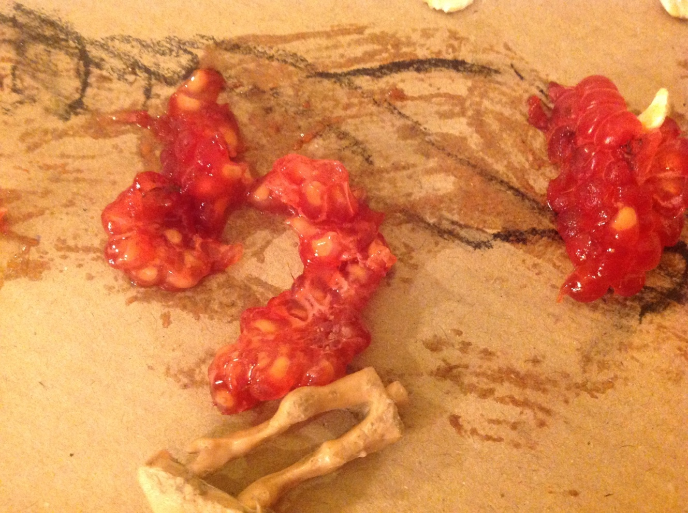

Figure 5

Our activity transforms objects and materials into inflamed tonsils or scraped flesh, something crushed and carnal, the missing torso of some creature pulling violent attention towards itself (fig 5). There are marks made over marks made, the juice of raspberries attempting erasure of deeper stains, only to deepen them. In action, our thumbs and fingers are as prosthetic extensions of our masticating teeth, they nip and pinch the cud, kneading and shifting matter through embodied intra-action, simultaneously drawing-out and drawing-in. We move in and out of the written word, as in the writing of this text, but materiality always drives the making of meaning, even as it is signalled by its absence.
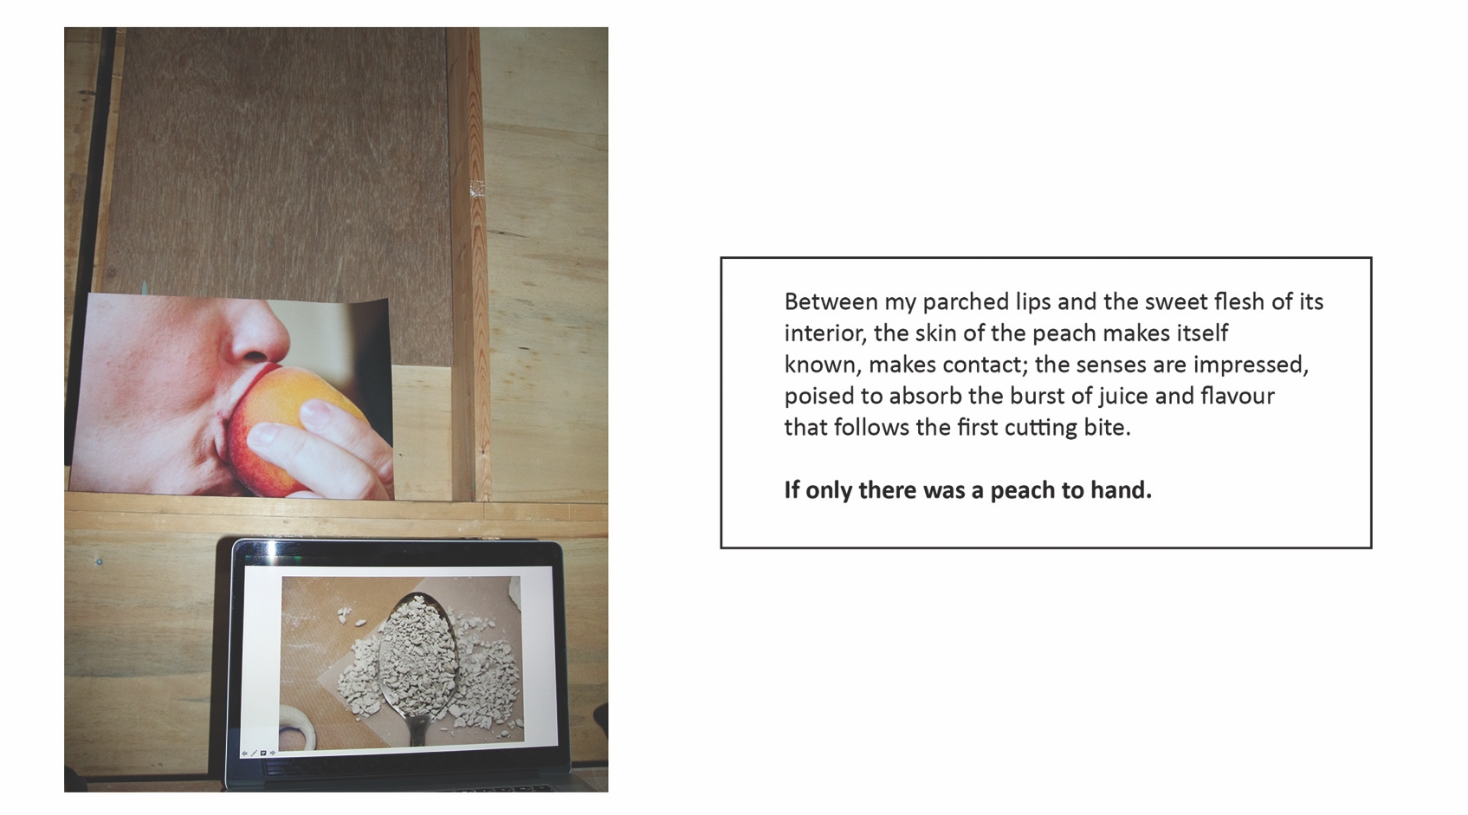
Figure 6

To make something your own, it has to yield. An object gives way to a narrative chain, disrupted by the first cutting bite. Writing too is bitten-into, broken-open, disrupted and re-formed through successive responses. We break the words and objects open in order to incorporate, own and know their potential and affordances. When a peach is taken from a bowl, what does it afford? How does it map the visual-verbal interface? Shall we peel it, eat it or otherwise document its arrival in our midst? ‘How’, asked James J. Gibson, ‘do we go from surfaces to affordances’?
…and if there is information in light for the perception of surfaces, is there information for the perception of what they afford? Perhaps the composition and layout of surfaces constitute what they afford. If so, to perceive them is to perceive what they afford. This is a radical hypothesis, for it implies that the “values” and “meanings” of things in the environment can be directly perceived. Moreover, it would explain the sense in which values and meanings are external to the perceiver. (Gibson 1979: 119)
Brian Massumi goes one stage further, emphasising agency for that which is afforded, whereby an ‘object’s appearance is an event’ which is ‘relationally activated’ (Massumi 2008: 5). Thus material (Fig. 7) might afford the relational response of a stretch.
The stuff of skin as material evidence might also be stretched to resemble the matter of metaphor or the surface of knowing. Punctured, torn, grazed, ruptured, cut, bitten into, sliced, incised, flayed, burst, shed or dead, skin changes through action and reaction, renewal, grafting, erupting: language itself is a porous skin, enabling and disabling, simultaneously. The digestive tract of knowing is engaged.

Figure 7
The skin-ego or psychic skin of psychoanalysis (Anzieu 1969, Bick 1968) might be transparent, floating, and ephemeral like the membrane that gives rise to an envelope. Like language, this benefits from being punctured, enabling fluidity to challenge solidity and invention and reflection to seep into one another as a form of utterance. The skin of the ego is liminal rather than subliminal, always in formation and always disintegrating. Stuff (and stuffing) is shaped and reshaped by skin’s propensities. Containing and enclosing in itself, skin is also imagined without borders, reaching out and stretching across cultures, divisions, gaps and opposing forces. Stretched under tension beyond endurance, (fig. 7) it gives way to rupture, catastrophe even. Thus Marsysas, the Silenus, was flayed alive because he had the courage to question the authority of Apollo. Our skin-as-word-made-flesh has travelled far, from the proto-Indo-European *sken-, to peel off, to flay.
Handling is disturbing. Eruptions happen, biting through the skin of experience. Skin touches object, surface touches surface, establishing relationships and engaging in dialogue with one another. Objects disagree with objects. They object to one another. That which we take for granted is open to disruption of causation. Our conversation turns and takes turns in unfolding.
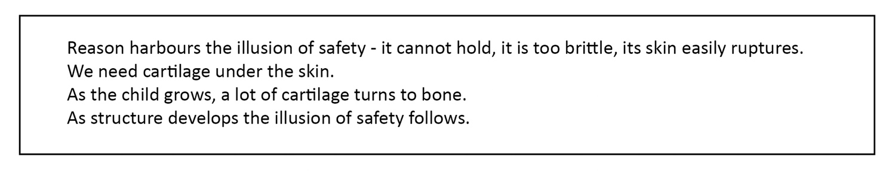
Figure 8

Within the envelope of the skin, cartilage is the connective, flexible tissue in the larynx, the respiratory tract, nasal structures and the external ear, as well as in the articulating surfaces of joints. The larynx, or voice box, forming air passage to the lungs and holding the vocal cords, enables the delivery of phonetic communication. It is active in the making (and hearing) of words. During swallowing, the opening of the larynx is closed by the cartilaginous epiglottis of which the glottis is the opening between the vocal folds. We cannot speak and swallow at the same time, yet the connective apparatus is essential to both processes.

Towards a digestive tract of knowing

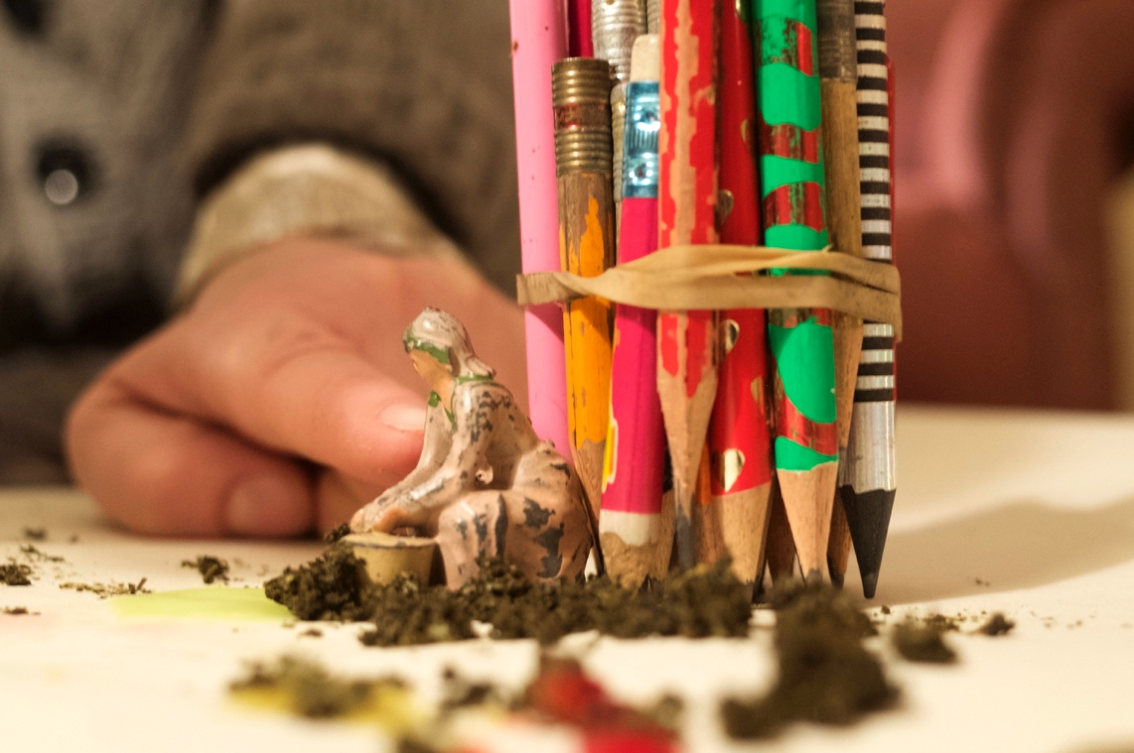

Figure 9
How does all this work on us? How is all of this mess ingested, how is it brought under some control without desiccation? The kind of speech acts or utterances we participate in constitute a pre-digestive state. We apply force on the material, we slow its free flow without killing it. We shape it, form it, congeal it into a bolus fit for passing into our pharyngeal muscles and alimentary canal. According to the psychoanalyst Wilfred Bion, ‘English betrays the widespread use of the alimentary metaphor when processes of thought are in dispute’ (Bion 1965: 90). But, is the focus to be on the inhalation and exhalation of matter and meaning, or on the ingestion of the bolus, or breath and bolus both? Naming what we are doing extends this riddle. For Bion, words wrap around experience, thus
giving something a name was a way of binding things together to prevent dispersal, the band around a bundle of sticks or ideas or observations, and nothing more. Having been given a name, however, it was then possible for the meaning of the bundle of ideas to grow naturally and progressively. (Symington and Symington 1996: 53)
But as Barad reminds us, this naming (language) can become uncomfortably sticky and thus we return, iteratively, to the provocative agency of material encounter. Hands hold forth, moving, enclosing, as ‘the band around a bundle of sticks’ (fig 9), becomes an extension of our thoughts, moving prosthetically as intermeshment of tools and gestures. As Massumi suggests, ‘(t)he thing, the object, can be considered prosthesis of the body – provided that it is remembered that the body is equally a prosthesis of the thing.’ (Massumi 2002: 95).
We see all of this from different vertices or points of view, and our vertices are always moving between subjects and objects. Our languages become layered, existing in a state of flux or reflux. We see whisks, wool, pistachios, balsa wood, hands, pen, traces of shadows, words and semi-colons as coexistent. ‘To shift from a vertex of one “sense” or “system” to another affords a way out of difficulty that use of one vertex alone makes impossible.’ (Bion 1965: 90) Even lines drawn with a bundle of pencils bound by an elastic band afford differently from the traces of the shadows of whisks drawn with a fine-liner pen (Fig.2). It is these vertices, multiple and variant in form, that are bundled and bound to form the bolus in the alimentary canal. The involuntary passage to peristalsis begins. We have engaged in the collaborative digestion of information by means of a shared conversational practice, probing the limits of (our) comprehension.
Charles Garoian tells the story of a group of students who each received a piece of wood as a starting point to explore transformation. One member of the group had sanded her piece of wood to sawdust. This became an ingredient in the biscuits that she made and that her peers and tutor ate and digested unknowingly during a critique of the task. This direct consumption uses the body as a driver to become both object and subject. This is an intra-active process, albeit literal in this instance; it is an uttering of gastromancy. As Garoian concludes, ‘bodies make artworks just as artworks make bodies.’ (Garoian 2013: 123)
A relationship between utterance (in Bakhtin’s sense) and artwork (in Garoian’s sense) constitutes an intra-active conversation (in Barad’s sense). Rather than elevating the utterance to artwork, as played out through Michael Craig-Martin’s An Oak Tree (1976), we are refiguring the artwork as utterance, mediated by the apparatus of metaphor. The aesthetic consequences are in the collaborative working-through rather than any specific visual or verbal outcome.
Our positioning is arrived at by our dialogic orientation towards an always temporary conclusion. We have been content to initiate and digest a playful relationship between belief and scepticism in which words matter, but not more than that which they represent. Barad offers a similar conclusion, thus ‘meaning is not a property of individual words or groups of words but an ongoing performance of the world in its differential dance of intelligibility and unintelligibility’ (____ 2007: 149). We conclude that the image (fig. 10) formed within dialogue embodies conversation rather than being an illustration of it. The group of words performing here have the same status as the materials in the image, but whether together or apart neither embodies the intra-active encounter as experienced around the table.
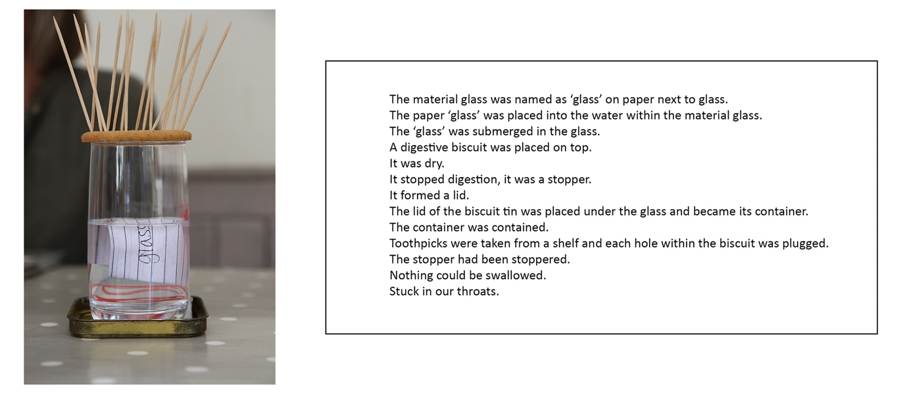
Figure 10

In developing this account as academic text, we are conscious of the protocol of accounting for our practice, of offering coherent explanations to ourselves and others, but we are perhaps more willing to be understood through the traces of dialogue as represented in object-image-word form. The event, the writing of the paper forced an inversion in the normal order of things, our things, our way of making meaning. A small catastrophe happened in the dissolution of our practice mind, but the use of written language in this article ensures that we continue to change and unfold. We are engaged in a practice which enables the agency of object-subject intra-action. There are moments of greater and lesser aesthetic valency, both ‘intelligibility and unintelligibility’ ebbs and flows as we grapple with what we are uttering. The judgement of these conversational utterances must be tethered to a process of intra-personal development as research-in-action within a specific context. To bring conventional visual aesthetics to bear on what emerges would, in the main, be an operation in an inappropriate register. These utterances can be simultaneously crucial milestones within a developmental journey towards a distinct art practice and dismissed or rejected on grounds of the conventions of visual aesthetics. There is a potential assumption that personal and interpersonal development within an arts practice and the making of art go hand-in-hand. Successful development and change can be made without art and successful art can be made that supresses or is indifferent to personal development. We sit in-between, forming our own register and making our own practice boundaries that we can rub-out, fret and reframe. The use of a pencil to punch out the shape of a boat from the sheet of corrugated cardboard (Fig. 11) leaves a jagged opening adept at holding a marble egg.; the waning of one dominant vertex and the waxing of another enables the aperture to become a mask or a new skin (Fig.1). We take turns in peering through and being peered at and the greater degree of embodiment changes the meaning of our mattering and the mattering of our meaning. The words navigate, adhesive and incantation and the phrases a putting to and a placing that our conversation had literally inscribed on the surface are set in flux by the vertex shift. A digestive apparatus of knowing is materialised, it goes beyond any intentions we share and is at the limits of our comprehension. It is a process of performative mattering, a mattering-as-utterance, both active and embodied.

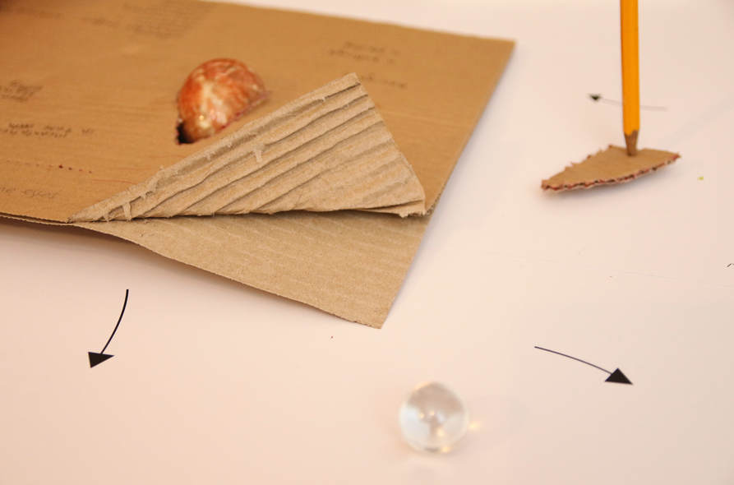
Figure 11

References
Anzieu, Didier (1989), The Skin Ego, New Haven: Yale University Press
Bakhtin, Mikhail Mikhailovich (1981), The Dialogic Imagination, (trans. Caryl Emerson and Michael Holquist), Austin: University of Texas Press.
Bakhtin, Mikhail M Mikhailovich (1986), Speech Genres & Other Late Essays, (trans. Vern W. McGee), Austin: University of Texas Press.
Barad, Karen (2007), Meeting the Universe Halfway: Quantum Physics and the Entanglement of Matter and Meaning, Durham and London: Duke University Press.
Barthes, Roland (1977), ‘Rhetoric of the Image’ in Image – Music – Text, (trans. Stephen Heath), New York: Hill and Wang.
Bick, Esther (1968), ‘The Experience of the Skin in Early Object-Relations’, The International Journal of Psychoanalysis, vol. 49, pp. 484-6.
Bion, Wilfred R. (1965), Transformations, London: Heinemann.
Corballis, Michael. C. (2003), ‘From Hand to Mouth: The gestural origins of language’ in M. H. Christiansen and S. Kirby (eds) Language Evolution, Oxford: Oxford University Press.
Deleuze, Gilles and Guattari, Felix (1998), A Thousand Plateaus: Capitalism and schizophrenia (trans. Brian Massumi), London and New York: Continuum.
Garoian, Charles R. (2014), The Prosthetic Pedagogy of Art: Embodied research and practice, New York: State University of New York Press.
Gibson, James Jerome (1979), The Ecological Approach to Visual Perception, Boston: Houghton Mifflin.
Massumi, Brian (2002), Parables for the Virtual: Movement, affect, sensation, Durham and London: Duke University Press.
Massumi, Brian (2008), ‘The Thinking-Feeling of What Happens’ Inflexions 1.1 (How is Research-Creation?) May, 2008, www.inflexions.org (accessed 28.08.17)
Symington, Joan and Symington, Neville (1996), The Clinical Thinking of Wilfred Bion, London: Routledge.

