Participants as Agents for Objects with Agency.

Within this chapter? I will question how the embodied encounter extends the understanding of matter beyond the habitual. I will question how object and subject reconfigure through a prosthetic connection and how interaction becomes ‘intra action’ (Barad) through specific encounters. The encounters that I will discuss take place within the space of the gallery. They are object encounters that interrupt traditional readings and are active provocations to look, re –look, think –re - think through a haptic connection - a touch. Whilst the prosthetics that enable a physical encounter will arguably shift, dependent on requirement, I am asking;

What if the prosthesis is on the body and extends from the body to reach towards art?
What if this reach between body and towards art is imagined as a bridge?
What if this bridge is learning?
What if this action is performative?

A performative material act of art pedagogy.

We navigate our surroundings through touch and stuff, forever in contact with something else, be it the floor, the wall, a handle, a hand. We are in it, and on it, between it and surrounded by it. We are outside of it and part of it, ‘from one side a thing among things and otherwise what sees them and touches them’ (Ponty, 1968). We are anchored as systems and beings within the world, always connected and wired? into the landscapes we inhabit. Moving within these landscapes only connects us with more - as we negotiate a place and an understanding of ourselves in it ‘suspended in a complex, and continuous back and forth between itself and artifacts, flickering that ultimately dissolves the distinction between them.. (Colomina and Wigley) (the plastic human page 23.) The everyday matter from mud to washing machines are like small punctuation points in this back and forth, they ground our known experiences and enable us to function with some level of control. The habitual processes of doing and being in our routines allows a silent relationship but vital agency with the complex and varied materials and objects we encounter. We can operate - by operating the materials around us, by making and manipulating and reorganising matter. We extend our experiences by physically engaging in the ‘processual rhythm’ (Massumi) of the object and the subject. They merge and fluctuate as we engage and encounter enabling boundaries to smudge. When these material encounters are with art objects they nudge the everyday, uproot routine and challenge our habitual responses to matter.

This physical engagement with matter is seen by Garoian (2013, p.124) as a ‘prosthetic embodiment’ where the materiality of the body and the art object extends from each other prosthetically. I will discuss how this extension from participant to object and back again can enable a fuller integration of subject and object and a more materially present encounter.
How can the prosthetic art object be understood within the context of art pedagogy? This enhanced experience of prosthetic encounter must be negotiated through an object extending from or connected to the body in some form. ‘The thing, the object, can be considered prosthesis of the body – provided that it is remembered that the body is equally a prosthesis of the thing’ (Massumi 2202, 95) This prosthesis becomes additive and rather than filling a void, or standing in for a physical loss, it’s corporeal attachment allows for an alternative material connectivity. It is not a compensatory replacement it is beyond the habitual and the ordinary. It is an enhancement that can enable an objects potential to form new ways of thinking through a corporeal encounter. These objects can offer more than themselves. ‘They are thoughts’ (Colomina and Wigley p.24).

I will separate this chapter into sections that explore notions of pedagogical prosthetics and discuss how the encounter with these ‘objects, these ‘thoughts’ changes both the participant and the artefact. Using fables as metaphorical devices to unpack examples of object encounters I will explore these ideas and experiences of using objects. The objects described have been made by myself or in collaboration.

I am interested in how fables act as small, theatrical narratives. They move quickly to provide a moral through dramatic metaphors and often animal or object transformations. They speak of mistrust, untruths, and disguise and yet these uncertain and unstable elements provide a lesson. They can be seen as strange pedagogical devices that questions success, ability, potential, perseverance and wisdom. All these terms that are so often used within learning to define the superior learner are provided through a fable. A pedagogical narrative. An object and character filled story with accompanying smoke and mirrors, decoys and misgivings. A fable is an event.

What fables I will use;

The tortoise and the Hare – the Hortoise

The emperor’s new clothes - the Sceptic
"unfit for their positions, stupid, or incompetent". Finally, a child cries out, "But he isn't wearing anything at all!"

Wolf in sheep’s Clothing – the Decoy
Beware of false prophets, which come to you in sheep's
clothing, but inwardly they are ravening wolves.

Tortoise and the Hare

This binary tale introduces two identities, two different characters both seeking a common goal. I will unpack the use of this fable through different encounters. One took place within the gallery and the other within two Universities. Through these examples of object encounters I am operated by the objects and I operate the objects and for differing ends.

Sainsburys Centre for Visual Arts
Feb 2017 description 1.

I stood in the gallery and unpacked the objects as people walked around me and I am generally ignored. I take out the first object, 2 shoe lasts joined on a band of elastic and I place them over my head and under my hair so that the shoe lasts are upended and sit like a hair band (hare band) on the top of my head. They are no longer shoe lasts they are ears.

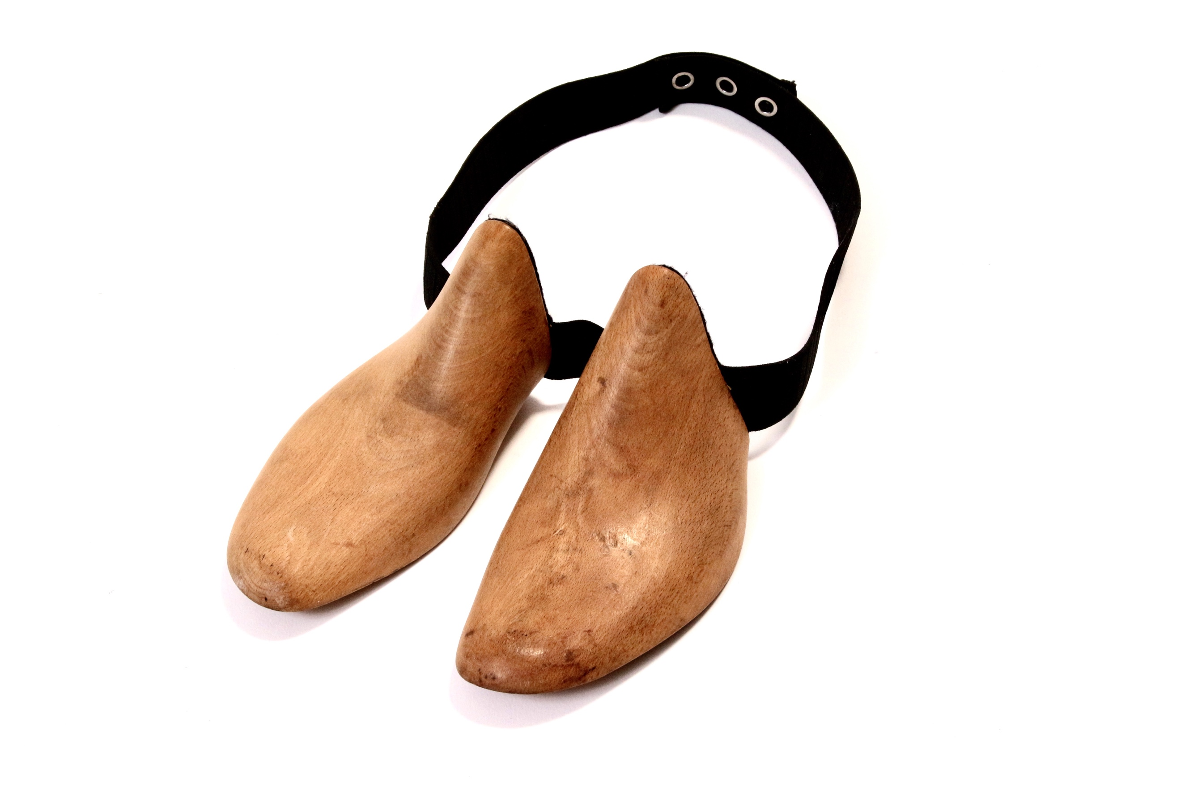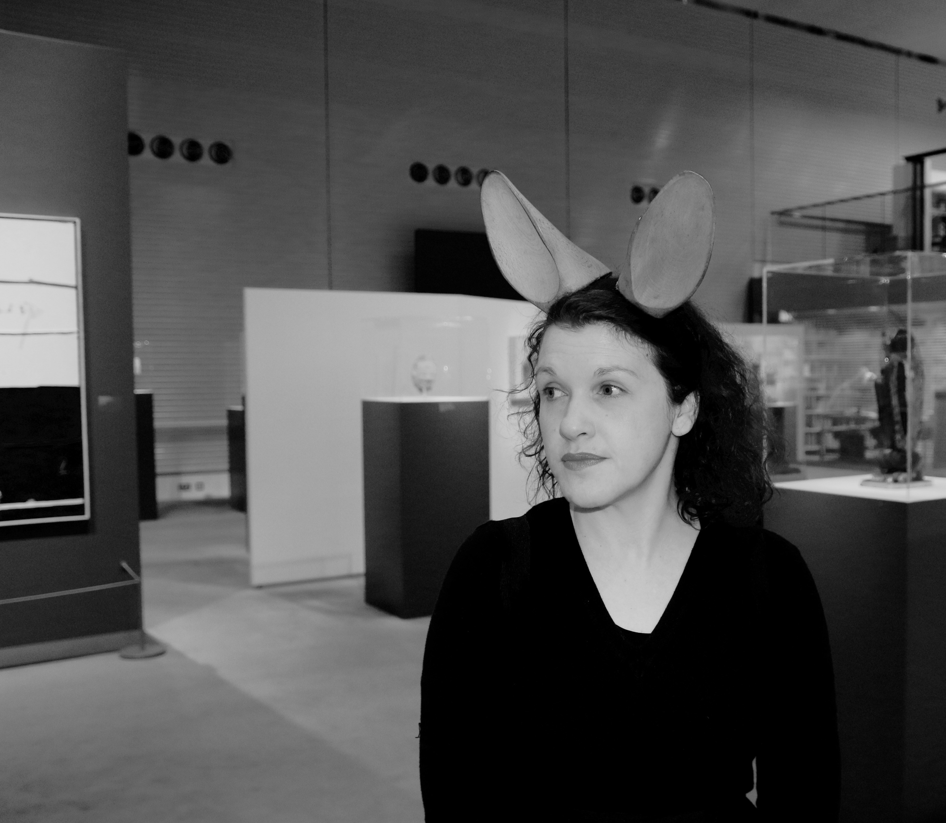

The ears are the ears of a Hare, listening upright and alert. I am focussed on how they feel on my head and how my posture has changed because of their presence on me, they are attached and extend. The shoe last-ness that is visually remembered within the object and the new pricked-up ears make me want to move. There is a sense of expediency. I am now noticeable in the gallery and no longer a silent figure. I am a focal point, people smile, laugh and stand by me, looking at me. 5 minutes earlier with no ears they would not have watched me or stood so close. I feel I am becoming an object, another object within the gallery ‘a things amongst things’ (Massumi) . As I stand in the space I feel my wooden ears which may be stand ins and imposters are heightening my experience in the space. I am vocally quiet but physically I am loud. EVENT

I unwrap the partner object and I bend down with my ears still on my head to pick it up. It is a wooden chair seat. The chair seat also has elastic straps that allow you to put on the object like a rucksack. It has a weight, feels like baggage literally and metaphorically on my body.

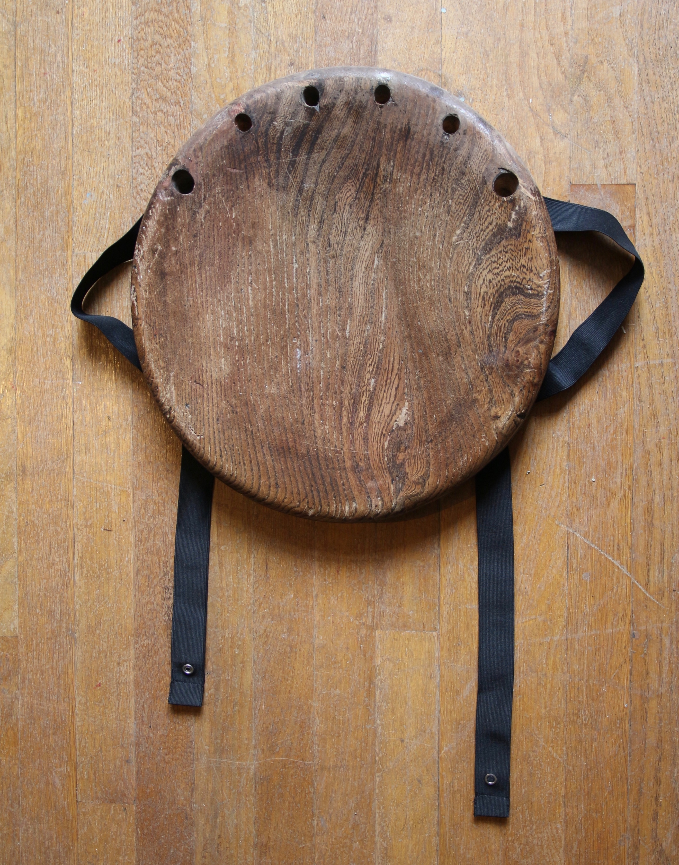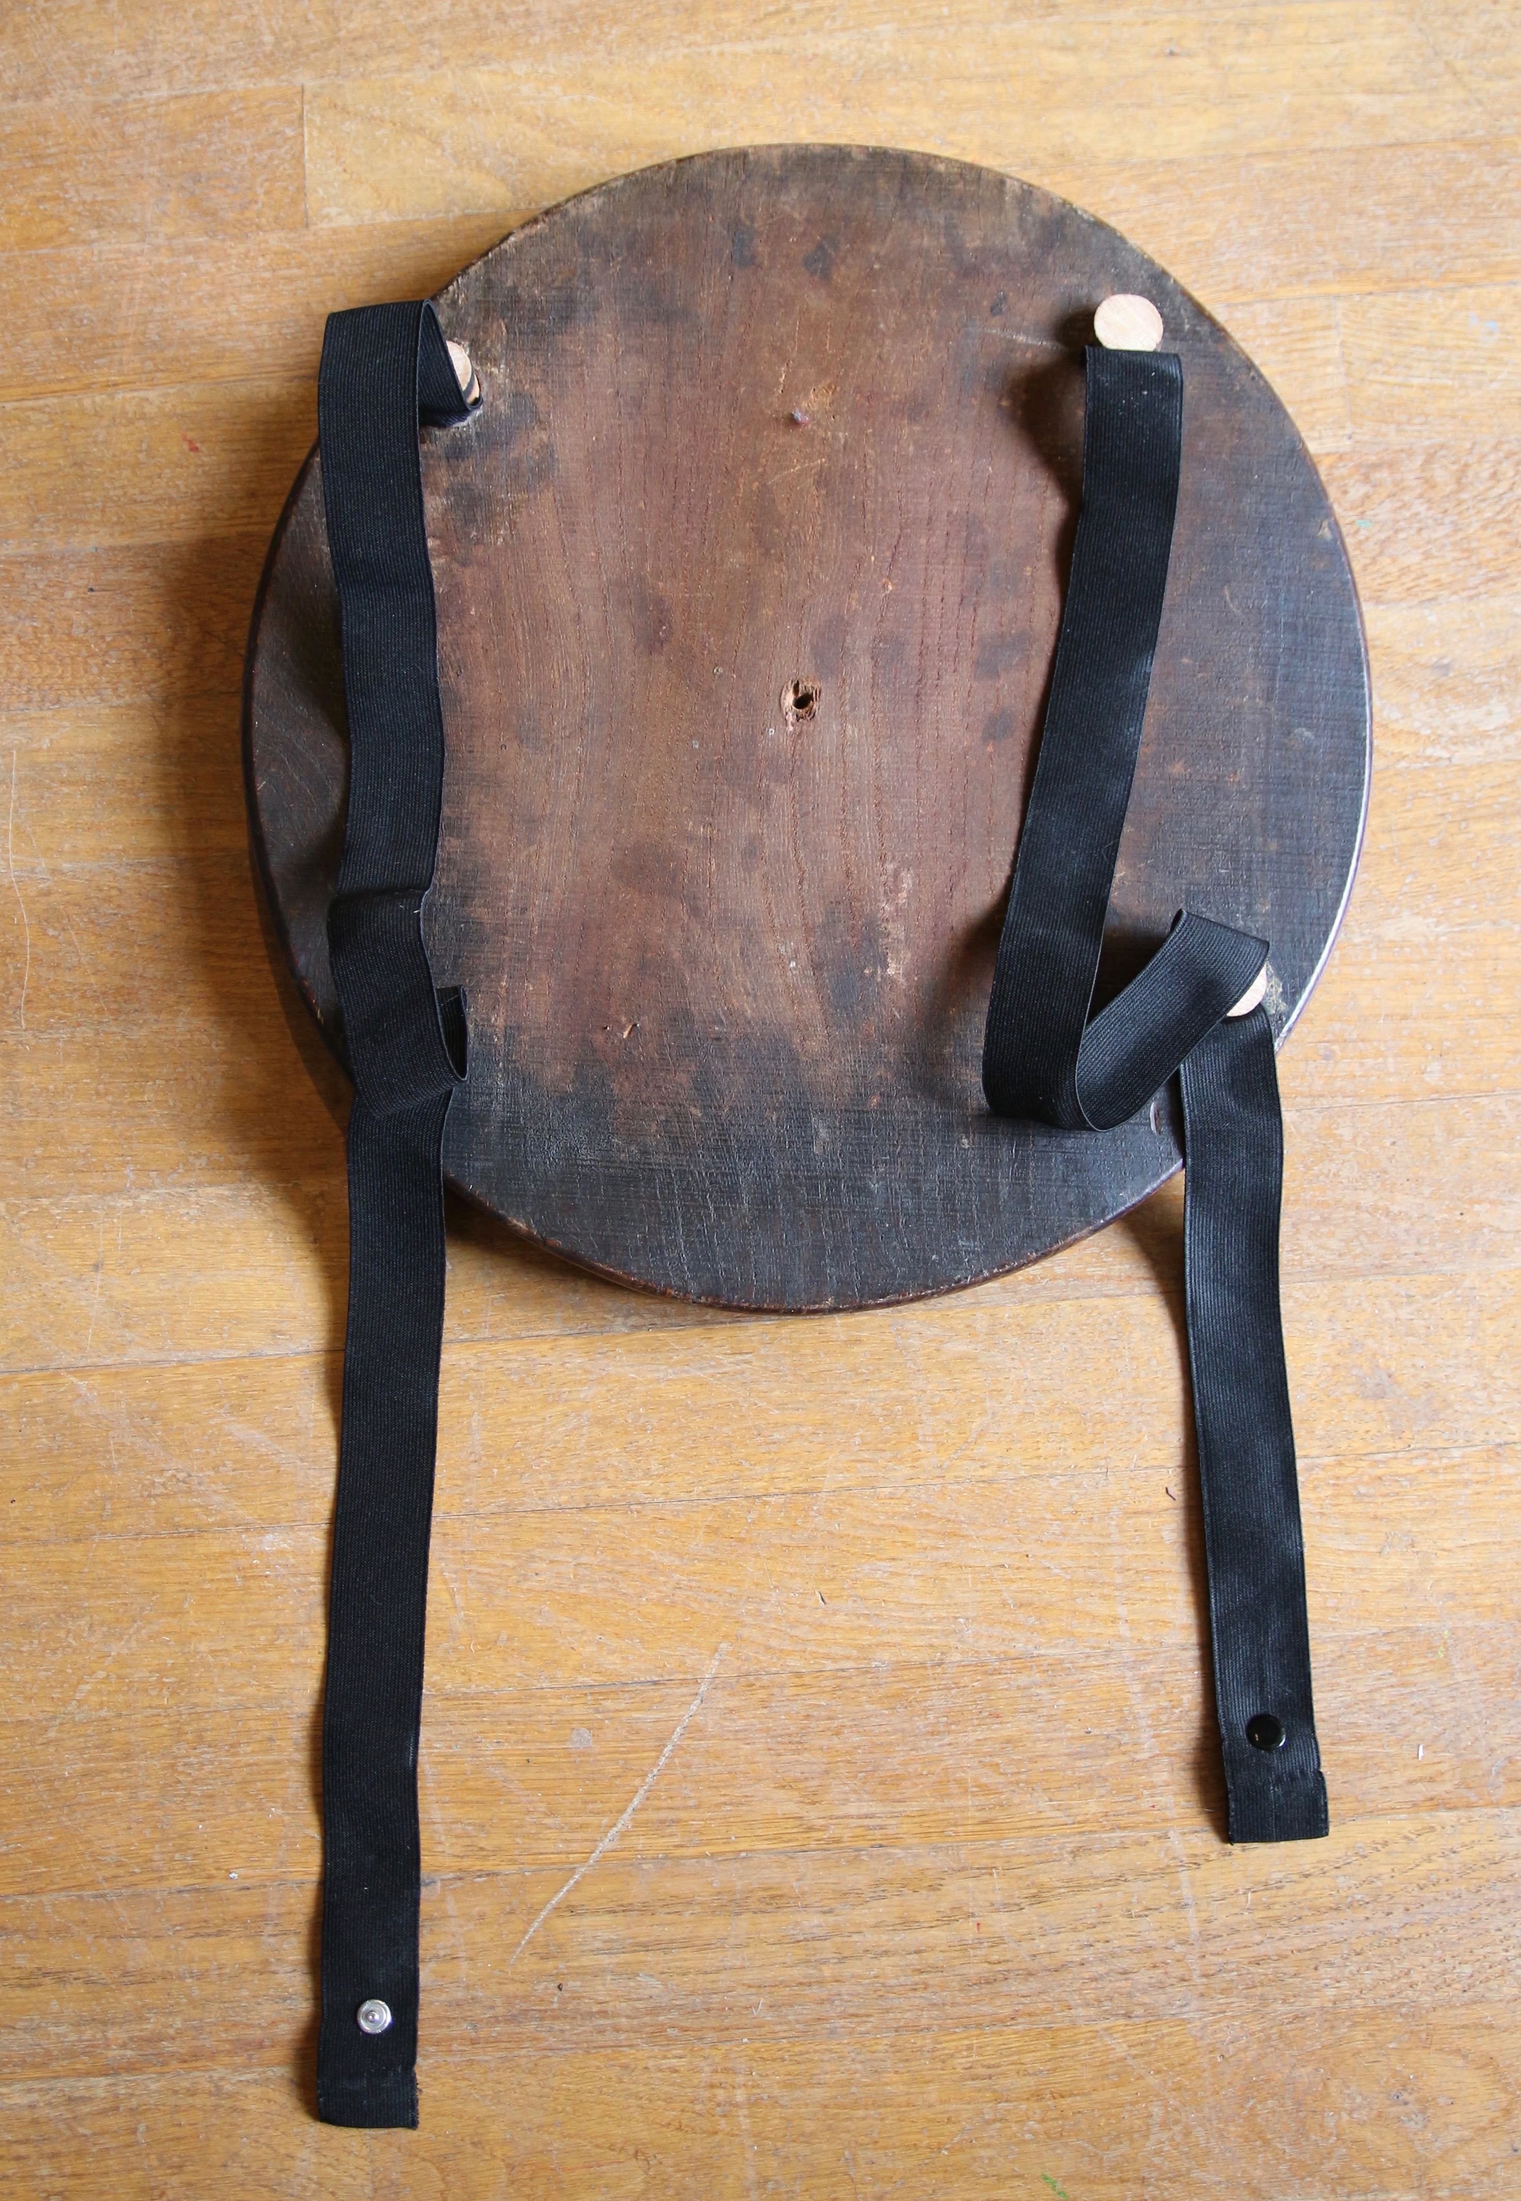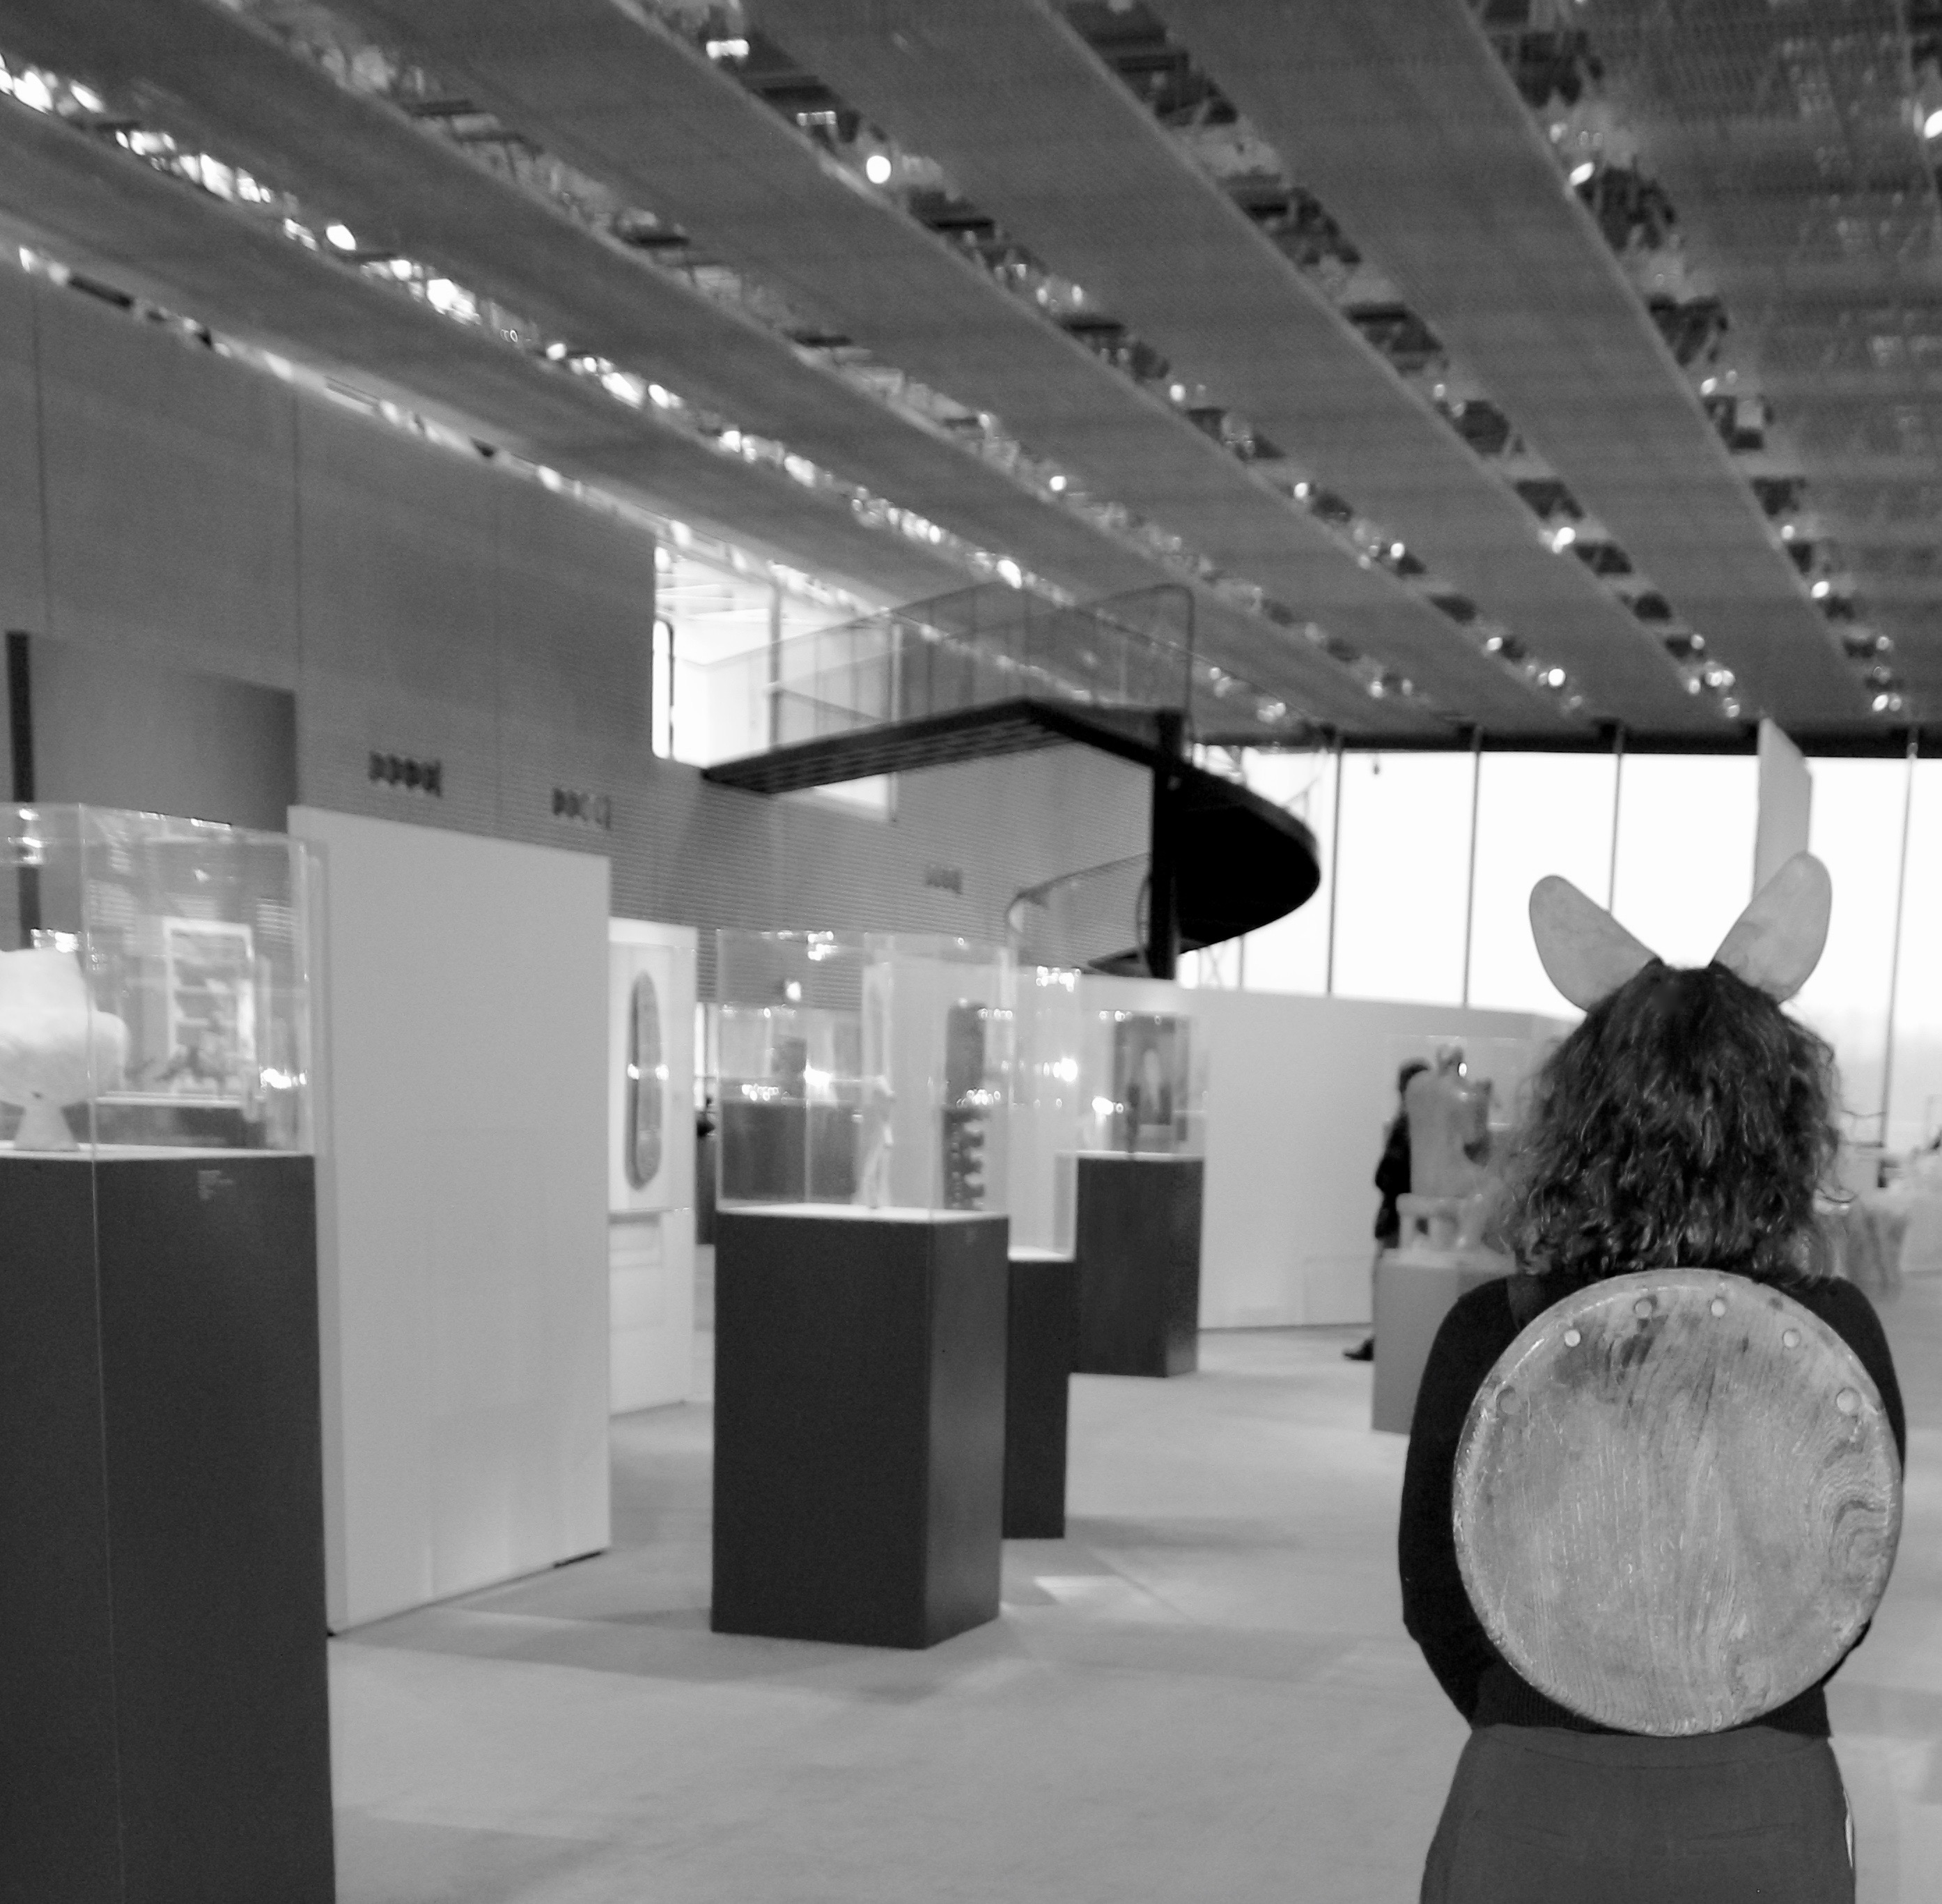

I am pushed into a more upright position but feel equip or ready, for something. The chair seat has become my shell, a protecting shield. I know it physically still references chair –ness, as with the other object you cannot escape its original identity. Mezerw regognition

The shield on my back makes me very aware of my stomach. It feels overly soft and vulnerable, it is not protected by a wooden shield, it is not extended from. It feels overly bodily and strangely exposed. The elastic fastens at the front of my body and its stretch is poppered into place. The objects have drawn my attention to my physical state my material body and whilst I renegotiate my identity the gallery visitors seem happy to watch.

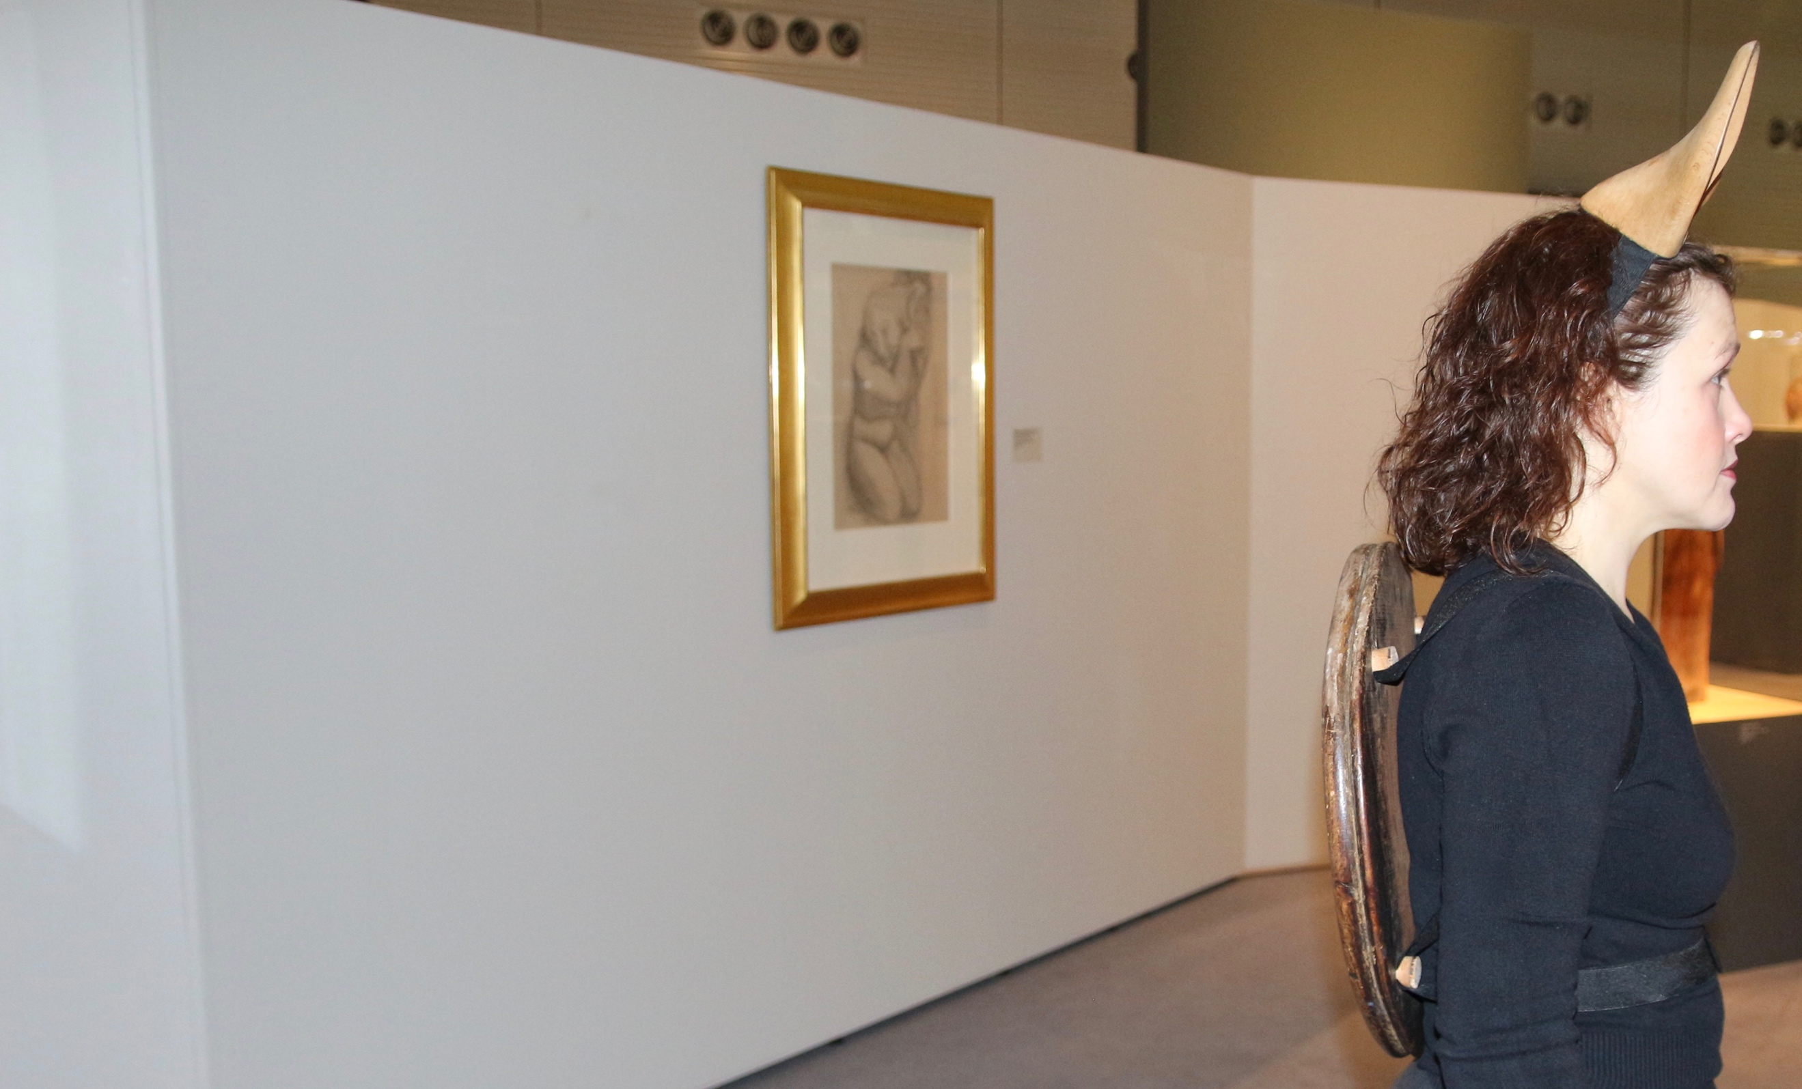

My body has become an active agent as I feel defined by the objects. I ma not just wearing these objects, they are on my body. I am connecting the two disparate elements. These new objects are in-between states of identity or meaning. I am a shifting site. These are de-familiarised (vygogsky schlovsky )objects and are at once both known and unknown. The material matter –ness has been altered. The materials dislocated from their origins of function. They have not become redundant through this dislocation they have yielded to become other. They have become ‘active agents’ (Van de Tuin 2011)) through their transformations.
I move differently and look with my ears at the objects in the cases and on display. I am free amongst them both at home and incongruous. I am recognisable, with my not ears and my not shell. I am carrying all their identities and mine.

They are ears, they are not.
They are show lasts, they are not
It is a shell, it is not.
It is chair back, it is not.
It is me it is not.

What are the new functions of these objects and who am I in the space between them. I am bridging their gap and from 2 objects they are operating together on my body as one as I become part of the narrative. I am prosthetically linked in the most direct and literal way by their attachment. I am matter and I matter (Barad 2014) in their effectiveness. Just as their identities have shifted so has mine. This disturbance on my body, agitates and provokes asking for new readings, interpretations and meanings. Mileaf (2010) questions how uncanny or surrealist objects use ‘juxtaposition as a strategy to incite corporeal disturbance’. The shoe lasts and chair back’s juxtaposition takes place through their placement on the body. The body is the connection point, it is the join. The differing roles or identities of the objects congregate on the body itself. They are encountered through touch but not through the hand. The ‘continuous interminglings of matter and meaning in the encounters of bodies, both human and non-human’ (Kontturi 2013 p18) congregate as I am activated by the event that my wooden appendages have provided.

When did this event begin, which element do we read as encounter? Is it the placing of the objects on the body, the wearing of them in the public space as they become performative, or the initial unpacking of them from the box?

Is there a need to set the parameters of this small transformative event? Deleuze talks of how ‘events float on the surface of bodies’ never actually existing or that they ‘sub–sist or per- sist’ between bodies. This floating suggests the connection with the body is on the surface, momentary, transitory and fluid. There is a fluidity to the shifting roles the objects, including my body have taken in the public space of the gallery. We (the objects) are all in close proximity and have been offered up to the surface of each other. I am interested in the definition of adsorption when a substance or molecule can hold on with a thin skin to the surface of something. An adsorption rather than absorption occurs as materials slightly adhere to the surface rather than seeping into the thing itself. Does this or can this moment of ‘only just’ touching – ‘only just’ sticking speak of a temporary prosthesis. Can a temporary adhesion still be an embodies encounter? Whilst the ears and the shell are joining onto me, they are on the planes of my body, the edge of it. They sit on my surface yet I am transformed. Everything is transformed from an original state by these prosthetic connectors. Normal reference points have been erased and everything becomes ‘familiar unfamiliar’ (Kaprow ). Only just attached the meanings are active, the objects and the body are charged and identified by the action they enable. Each element is in the middle of something, resonating within an encounter. This performative act references Lygia Clarks approach to the act of making and being in the moment of its emergence and its activation; ‘The only thing that matters, is the act – in- progress’ she states (Clark 1960 p.254). This notion of the ‘act – in – progress’ seems to demand not only an event but an environment for it. Is this environment the body, is this the surface of the event.

I wanted a physical example of an experience. I wanted to have objects that could perform this experience. An exemplar of it. The objects visually and directly link to the fable but could I change the moral, manipulate the narrative and embody it. Not through a literal retelling and consciously avoiding illustration but a reordering of the materials and the narrative. Mileaf discusses how the artwork ‘becomes a switching station, or sometimes a provocateur, in encounters that lead to the realignment of the perceiving subject’ p11 please touch. Through the objects on my body I become a ‘switching station’ and myself and the material yield to change my mode of operation within the gallery. Taking Deleuze’s ( p48) example of how thinkers can become ‘actors’ both present and active within an event or ‘drama’; do I become the actor, dressed up and performing a representation of a fable? Am I the event, the actor, the encounter and the environment. Have I chosen to play all the parts? The Tortoise and the Hare, the Hortoise.

Whilst Deleuze uses drama or ‘dramatization’ as a thinking mechanism to extend understanding can this correspond to Clarks earlier ‘act –in - progress’? Both are unified by the event and the encounter with other, whether human or non-human and both place significance on the moment of - thinking and doing or of meaning and making?

My making meaning doesn’t start with the upending of the shoe lasts on my head and their transformations to become ears. It starts with the possibility that a shoe last can become ears. This isn’t a simple representation it is a folding and unfolding of object –body –subject where objects are multi layered, multi modal. Barad unpacks the layering of material relationships, the constant ‘intra actions’ focussing on how the ‘matter –in-the-process- of- becoming is sedimented out and unfolded in further materialisations”. (Barad 2003)

Therefore, we cannot start with a blank canvas as the objects are already more than themselves, removed from their functions to take on new ones., connected and reordered to make new sense. There has been a pre –practice, a before, that enables the event. The objects are already altered, already moved from last-ness and chair –ness. They have turned into something else to enable something else. Their materiality is a series of transformations from their original matter, my first encounter is within the studio in their remaking, the second on the body, the third in the gallery. A material meaning navigation that ‘floats’.

The ordinary is rearranged but still present. We can still grasp it and know it but as Stewart (2007) discusses ‘The ordinary can turn on you’. This allows us to perceive the ordinary as more than itself, determining a way of seeing, or even as hinted by Stewart becoming an adversary. This anthropomorphising allows a certain relationship and closeness with the objects and the possibility of seeing them as ourselves, like ourselves. The non-human becomes not only more human but more powerful. Their potency and agency is amplified and they become more problematic and resonant. The use of ‘drama’ becomes more pertinent now as things are reframed and ‘act’ and are acted on within new experiences/events.

I will go to contextualise how these peculiar objects act as a metaphor for learning and that this is more than ‘staging pedagogy as a visible encounter” (Verwoert, Scott, Elms, & Cahill, 2010, p.182), it is the understanding that the learning encounter reaches full potency through a physical exchange with material form.

Presenting the Hortoise.
February –March 2017 Goldsmiths and Birmingham City University

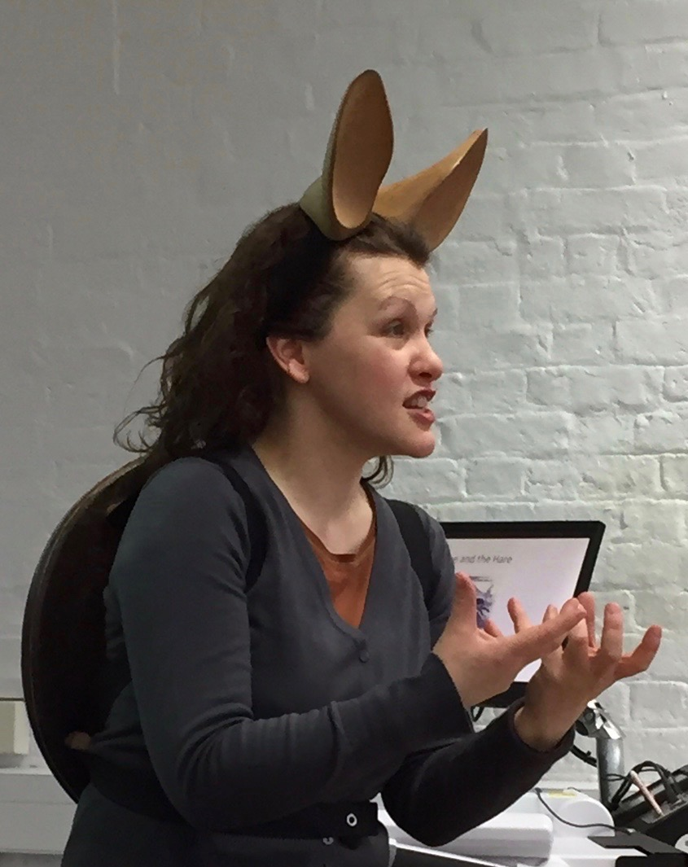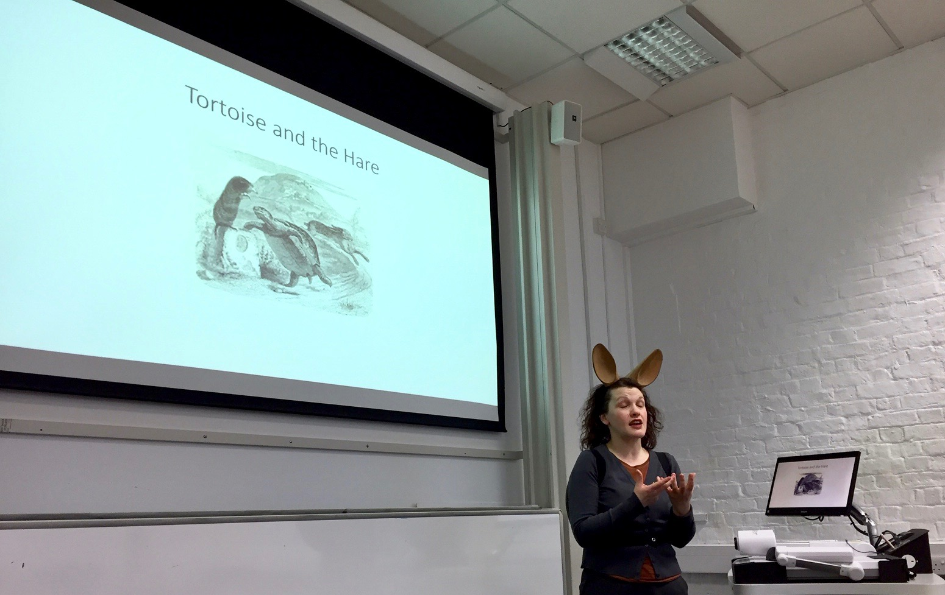

We trade off awareness for the avoidance of anxiety when new experiences are inconsistent with our habits of expectation, which can result in areas of meaninglessness. To provide meaning, we may resort to the psychological mechanisms of self-deception. (Mezirow p63)
The story of the tortoise and the hare is well known with its moral of ‘slow and steady wins the race’. By deciding to shift the fable beyond the reliable tortoise and the egotistical hare towards a tale learning, and learning trans formatively. This assumes a success and an assumption that the hare could have won if he wanted to. The fact that the tortoise simply benefitted from the hare’s carelessness and self-importance preoccupied me. The tortoise no longer seen as a winner is only rewarded with accidental success. The objects that I made reference both characters as discussed earlier but I want to unpick the messages that the objects on my body provide and how I identify them within the context of a learning process. The objects are carrying meanings

The yielding and openness required to engage with learning can often generate a vulnerability as one is destabilized and truths shift uncomfortably and new knowledge gathers. The identity of the last and chair has changed from their original state to a potential new readings, their original are destabilized too. object and learner yielding. This particular shell whilst protecting the back, leaves the chest and the stomach vulnerable, overly soft in comparison to the hard-wooden objects. The objects make the participant alert, attentive, protected and still, upright and listening whilst vulnerable and open. A transformation occurs that enables a reordering and renaming of the material objects for a new narrative or function. The body plays its part.

Certainly, within a learning environment steadiness may equal concentration or having attention on a goal and the carelessness of the hare may in turn equal a haphazard and egotistical approach to success. What is interesting is the unpicking of the tale as an illustration of how the role we take positions us. How do we consider our openness and ability to yield to an effective learning process? After discovering a small aside about the story, I became interested in how my recent work mirrored the story. A fable becoming an adopted metaphor?

gilles deleuze key concepts sense series. Within the domain of common sense, then, knowledge is reduced to recognition; we know that the dog we see is a dog because we recognise it as the same dog we have already perceived, imagined or remembered it to be. Clearly, recognition and common sense function to domesticate difference by dismissing as inconsequential all of the details about this particular dog, at this particular moment, that might prompt us not to recognize it as a dog. We miss an encounter with this particular dog, and settle for a dog that represents our prexisting Idea of dog-ness (DR:131-7).

It is more than ‘staging pedagogy as a visible encounter” (Verwoert, Scott, Elms, & Cahill, 2010, p.182), it is the understanding that the learning encounter reaches full potency through physical exchange with material form.

Does slow and steady really win the race and do we need to differentiate between the intentions and ability of both creatures to discover a moral or message within the fable?
Using this fable to develop an analogy for learning I was struck by whether slow and steady was reflective of the motivated push needed for transformative learning to take place

Designed artifacts have as much agency as the animal that seemingly produced them

We are all simultaneously in the middle and in between meaning and definitions ‘…somethings happening. Try as we might to gain an observers remove, that’s where we find ourselves; in the midst of it. There’s something doing. This is where the philosophical thinking must begin: immediately in the middle (deleuze and Guattati 1987, 21-23, 293). Semblance intro

Roger Sansi suggests that’ If we see the artwork as a mediator, or shifter, rather than the endpoint of a chain of casualty, we move from the agencies it contains to the agents it can possibly entangle, from ‘then’ to ’now’, past to present. P 56 art anthropology.

Wolf in sheeps Clothing

In reading about the ingredients required to allow an event to successfully take place it is clear that the emergent quality of the experience requires the rational, normal, known - knowledge base to take a secondary position. The experience of the event has to be ‘experienced’. An attempt to plan a reaction in adance or to negotiate something before it has even begun dilutes the process of being present in an event. Being – in- the event. That is not to say that there isn’t a case for imagining connections or trying to grapple with what potentially might happen. However there is a need to allow the event to evolve and surround us, preventing the objective self for emerging and dictating. There should be an expectation and understanding that a new experience has to be ‘new’ and can therefore never be completely known before hand.

P19 thought in the act.

‘The problem remains for us that the impulse to identify an experiential event with a brain state tends to take precedence, and is often given the first and last word’

The term brain state seems to galavnuse a position of intentionality, of order and control. The silencing of the ‘brain state’ therefore surely requires a participant or lenere to operate a new mode of experiential apparatus. To trust that an experience may maen an encounter with unfamiliar stimulus, providing an uncomfortable or even vulnerable state can be seen as disruptive and even alarming.

Mezerow quote

Sorhed objects require this shift from ‘brain state’ towards entrainment?
Expand on entrainment….

The encounter with them can be ‘felt’ physically and emotionally if the reasonable, sensible, knowing aspect is left temporarily to one side. As massumi p11 states the ‘ the mode of existence has to do with the emergent quality of the experience, not with the factually cross – checked identity of the objects featuring in it’

We often talk of the ‘gut instinct’; the intuitive thought process that is almost embodied through a physical sense of being - in - the decision process of thought. To hurdle the ‘gut’ inevitably encourages the brain state to rear its head again. We look for the way to make something safe, or known and the true experience can be thwarted by reason. The instinct is often queried or doubled by peoples initial encounter with sorhed objects. In the first moments of being presented with the uncanny, known unknowing sorhed object the gut often wins. The experience of touching these particular objects; with their shaken up functions and identities, often overpowers the rational. Therefore personal resonances surge before any ‘cross checked’ facts develop. This is a multi modal process of yielding. The objects through their creation have had to yield and lose their individual function through a fusing of two identities. Then the participant’s brain state has to equally yield and give way to a process. Truth procedure? badiou

The participants have to be confident and contained within a group to be able to engage with the material encounter; the weight, form, and texture in their hands. The unnamed object waits to be temporally claimed by the participant through their capacity to ‘grasp’ (in all senses) the encounter.

The initial questions or responses that are generated through the physical act of holding and attending to the objects, free flows. With speed there is a gathering of dialogue that is spoken aloud. A knee jerk reaction of language that often attempts to name and identify the object. This verbal identification of the material, held in the participants hands, is often accompanied by laughter or wry smiles that wobble between amusement and anxiety.

However for the skeptic the brain state is strong here and it takes hold and throws away any potential for other possible truths other than a statement of material naming. The skeptic will list the material attribures of the object; ‘It is wood and metal’ and ‘that is all it is’, ‘it reminds me of nothing’, ‘it isn’t important’. This position momentarily controls the encounter and makes the skeptic, for that moment, the one with knowledge. But what knowledge is it and where can it lead? The statements the skeptic makes are cul de sacs to an experience or to learning within an experience. ‘ learning involves construing and appropriating a new or revised interpretation for guiding action’ p31 dynamics of making meaning. Transformative dimensions of adult learning. Mezirow
So whilst this moment of power and control states a position, it is a position that without yielding is anchored and in fact can become for the skeptic - a dead end.

The power of the experience of being presented with or holding a sorhed object can create a potential for fear, or specifically a fear of being duped. This is particular and common and for the skeptic the objects take a specific and powerful role. The objects in this case are perceived as tricks to trap or tease. Smoke and Mirrors or the emeperors new clothes. Interestingly the objects do the opposite as there is no trap and they do tell a truth, it is just that it is a different truth. The objects have an identity, just a different one that is newly formed and needs negotiating through the encounter. Most importantly the generosity of the objects can be missed or avoided if there is no yielding by the participant of the position of already formed knowledge.

One person opened an object, a stone covered in read wax, someone next to them said its an apple, the facilitator said what is it, he said it is not like an apple it is a stone with wax on it. There was the voice of the skeptic; I felt a pull of recognition, as I knew that someone needed to take this role within the group. He had said a truth; he said what he saw, what he wanted to see and nothing beyond it. The facilitator didn’t ask him anymore and moved on round the table.

I was conscious of the earlier skeptic and the stone covered in wax that he had chosen. I watched as he attentively listened to others in the group and moved in closer to hear them. All the time he moved the stone in his hands and I knew the wax that coated the flint (formed from the wax around cheese) would be getting warmer and tackier in his hands. I wondered how he felt and why he hadn’t rejected his object. I was waiting to hear his response.

He moved the object in his hands holding it up at times when he spoke, ‘It is still a stone with wax on it,’ he said. ‘I chose it because I like rocks and I was thinking of them in this space as an organic presence in this space. Then I thought if this object has no real function then actually what are the functions of any of the objects in this space. How do we understand them?’

The group commented on both ideas of status and of knowledge. I had so many things I wanted to say but remained quiet probably nodding too often and I felt his thoughtful contribution as a change in his position. The wax/stone seemed suddenly like a cricket ball as though it was caught and held in his hands but potentially leaving a stain. Both object and participant were softening quietly like the wax in his hands.

